

**Diagnostic Evidence Co-operative (DEC) Newcastle**

Evaluation of the two-step diagnostic pathway for familial hypercholesterolaemia in primary and secondary care

Authors

NIHR Diagnostic Evidence Co-operative Newcastle upon Tyne, UK, NE2 4HH  
Joy Allen  
IVD evaluation methodologist  
  
Michael Power  
deputy director

Dermot Neely

Angie Silmon

Paul Brennan

Michael Wright

Ann Curtis

Ciaron McAnulty

# Abstract

## Background

The National Institute for Health and Care Excellence (NICE) have recommended patients with a clinical diagnostic of familial hypercholesterolaemia (FH) genetic testing to confirm the diagnosis and identify affected relatives. The North East North Cumbria has recently established a two stage, `chip and sequence’ testing strategy to deliver FH genetic testing for FH to the region. The `chip and sequence’ approach comprised of an initial screen with a rapid genotyping test for detection of the 52 most common mutations occurring with a high frequency in the region. If no mutation is detected and further testing is indicated through an MDT, then comprehensive full gene sequencing using next generation sequencing technologies (NGS) is carried out.

## Objectives

To validate and optimize the use of this two step ‘chip and sequence’ diagnostic pathway and to determine the cost consequences of this approach.

## Methods

From June 2014- June 2015 258 patients from the Northern Clinical Commissioning Forum were referred for genetic testing if they were clinically diagnosed as likely to have a genetic mutation associated with FH. Those who were not routinely tested with NGS as part of the pathway were tested retrospectively in order to determine the diagnostic accuracy of the two-step pathway as compared with NGS of all those referred. A simple cost comparison determined whether this approach was cost saving.

## Results

92 (36%) of the cohort were found to have a mutation associated with FH. 90 of these were picked up during the two-stage `chip and sequence’ approach. The sensitivity and specificity of the two step testing procedure as compared with NGS are 97.8% (95% CI: 96.0% - 99.6%) and 100% (95% CI: %- 100%) respectively.

The cost per patient for the two step diagnostic pathway was £358.14, which represents a saving of £41.86 per patient when compared with a testing strategy using NGS only.

## Interpretation

A diagnostic pathway for genetic testing which incorporates the use of a two-step ‘chip and sequence’ approach represents cost savings for CCGs. Continual feedback to optimize the chip to include all regionally frequent mutations is recommended. Further refinement of clinical scoring criteria to include age gender specific nonHDL cut-offs as well as chip optimization to include polygenic risk markers follows this work.

# Introduction

Familial Hypercholesterolaemia (FH) is a genetic disorder characterised by high LDL-cholesterol levels causing premature cardiovascular disease. Although one of the commonest inherited conditions, thought to affect around 1 in 250 people, it is asymptomatic and therefore under-diagnosed with 85% of those affected remaining unidentified. Untreated, people with FH are at risk of major cardiovascular events early in life, typically in their 40’s or 50’s. The key to improving outcomes is early identification and initiation of high intensity statin treatment, effectively eliminating the excess cardiovascular risk associated.

Cascade testing of relatives of patients with genetically confirmed FH is the most effective strategy for early identification of undiagnosed individuals. In 2008 the Institute for Health and Clinical Excellence (NICE) published guidance (CG071) recommending as part of specialist assessment, patients with a clinical diagnosis of FH should be offered genetic testing to confirm the diagnosis and identify affected relatives.

In April 2014 The Northern England Strategic Clinical Network Lipid Specialists Advisory Group secured the support of the Northern Clinical Commissioning Forum (13 CCGs) and funding from the British Heart Foundation (BHF) for two nurses and one administrator to enable the establishment of a region-wide Familial Hypercholesterolaemia (FH) Genetic Cascade Testing Service.

The NICE Diagnostic Guidance (DG2) provides an evaluation of technologies that assess a known sub-set of mutations and concludes that greater health benefits can be achieved through the use of comprehensive genetic analysis. Hence restricted “common mutation” tests are not recommended.

However, it is important to consider the potential cost savings a rapid, genotyping assay for common mutations can offer. Therefore, at the same time the regional genetic testing strategy was being rolled out, funding was granted from the Academic Health Science Network (AHSN) for a one year project to evaluate alternative genetic testing strategies.

## Methods

Patients presenting to primary care practices within the Northern Clinical Commissioning Forum (13 CCGs) were referred for genetic diagnosis if they had Dutch Lipid Clinic Network (DLCN) Score of greater than 5.

These patients underwent the two stage testing strategy as part of a service improvement project in the North East North Cumbria region.

The Northern Genetic Service in collaboration with NewGene developed a bespoke two-stage ‘chip and sequence’ genetic testing strategy. The first step is a rapid, relatively low cost genotyping assay for 52 of the most common mutations associated with FH (these mutations are listed in Appendix A alongside their frequency of pick up). This assay is run on a high throughput Sequenom™ MALDI-TOF platform available at NewGene.

All patients referred for genetic testing (index cases) during theperiod June 2014-June 2015 were testing initially tested using the ‘chip’ assay on Sequenom™ platform. If no mutation was detected using the chip test on the Sequenom platform, a multidisciplinary team met to discuss the case and determine whether further, more comprehensive genetic testing with next generation sequencing (NGS) was required. If the index case was referred, full genetic testing on the Illumina MISEQ next generation sequencer was carried out, also at NewGene.

Retrospective NGS testing of those index cases not referred for the second stage testing allowed determination of the sensitivity and specificity of the two-stage ‘chip and sequence’ approach.

Phenotypic data from the genetic testing referral form was combined with the genetic testing results in order to identify opportunities for improvement in the referral process and increasing the pre-test probability.

## Demographics

Table, age, sex,

## Results

During June 2014-June 2015 258 patients (index cases) across the 13 CCGs of the Northern CCG Forum likely to have a mutation familial hypercholesterolaemia (FH) underwent genetic testing for FH.

Of the 258 index cases, 256 were tested with the genotyping assay on the Sequenom™ MALDI-TOF platform as the first line of testing in the ‘chip and sequence’ diagnostic pathway.

Two of the index cases were immediately tested with next generation sequencing on the basis of the Multidisciplinary team’s (MDT) decision and no mutation associated with FH was detected (NMD).

Of the 256 tested with the chip, 47 (18%) were found to have a mutation known to be associated with FH (MD). One of these was further sent for full gene sequencing and confirmed to have a mutation.

The MDT reviewed the remaining 210 cases. 167 of these cases were tested using next generation gene sequencing, of which 43 (26%) were found to have a mutation. Figure 1 shows the testing pathway for the index cases and Table 1 summarizes the index cases results.

## Accuracy of ‘chip and sequence’ diagnostic pathway

To assess the accuracy of the two stage testing process, 41 of the remaining 42 index cases were retrospectively tested for a mutation and it was found that 2 index cases with mutations associated with FH were missed with the two-stage ‘chip and sequence’ diagnostic approach.

The sensitivity and specificity of the ‘chip and sequence’ diagnostic pathway are 97.5% (95% CI: 96.0% - 99.6%) and 100% respectively (see Table 2 for the contingency table).

The index case which did not undergo full genetic testing was removed from this analysis.

## Cost of testing

The cost of the first stage ‘chip’ test was £100 whereas the cost of the second stage ‘sequence’ test was £400. These costs were correct at the time of the project and quoted by the testing laboratory, NewGene.

If all patients were to undergo full gene sequencing, the cost for the full cohort of 256 patients the cost of testing would be £102,400 (see Table 3 for a full breakdown of costs). The chip and sequence approach realises a saving of £10,000 for the full cohort and £42 per index case.

The cost savings are largely driven by the prevalence of mutation positive index cases (probands) in the cohort. Figure 2 illustrates that with the current cost of the tests quoted for this manuscript, the two-step chip and sequence diagnostic pathway will be cost saving when the prevalence of FH in the cohort undergoing testing is greater than ~25%. The savings continue to increase as the prevalence of FH increases.

The prevalence of FH in this study was 36% therefore further savings could be accrued if this was increased.

## Opportunities for improving the genetic testing referral criteria.

The current referral criteria used is based on phenotypic scoring system the Dutch Lipid Clinic Network Score (DLCNS) REF. The DLCNS is a validated set of criteria based on the patients family history of premature cardiovascular disease (CVD) , their own CVD history, physical signs such as the presence of tendon xanthomas or arcus cornealis and their untreated and fasting LDL cholesterol levels (LDLC).

DLCNS results were available for 254 of the index cases, 91 with a mutation detected and 163 with no mutation detected. The boxplot in Figure 4 illustrates that there is a slight correlation between an increased DLCNS and index cases with a mutation detected (RSQUARED VALUE).

The specific LDLC cutoffs applied in the DLCNS critera are independent of age and gender, therefore their diagnostic yield may vary according to these factors. The scoring criteria and therefore the pretest probability of FH may be increased by the use of age and gener related LDLC centile thresholds based on nationally representative general population data.

## Derivation of age and gender related centiles

SEPARATE PAPER. APPLICATION TO THIS COHORT.

## Limitations

Did not take into account time difference in result availability

Full cost-effectiveness analysis needs done

## Demographic data

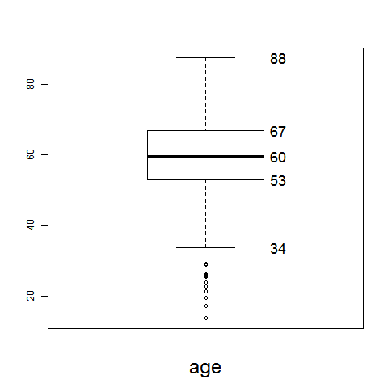

### Dutch Lipid Clinic Network Score

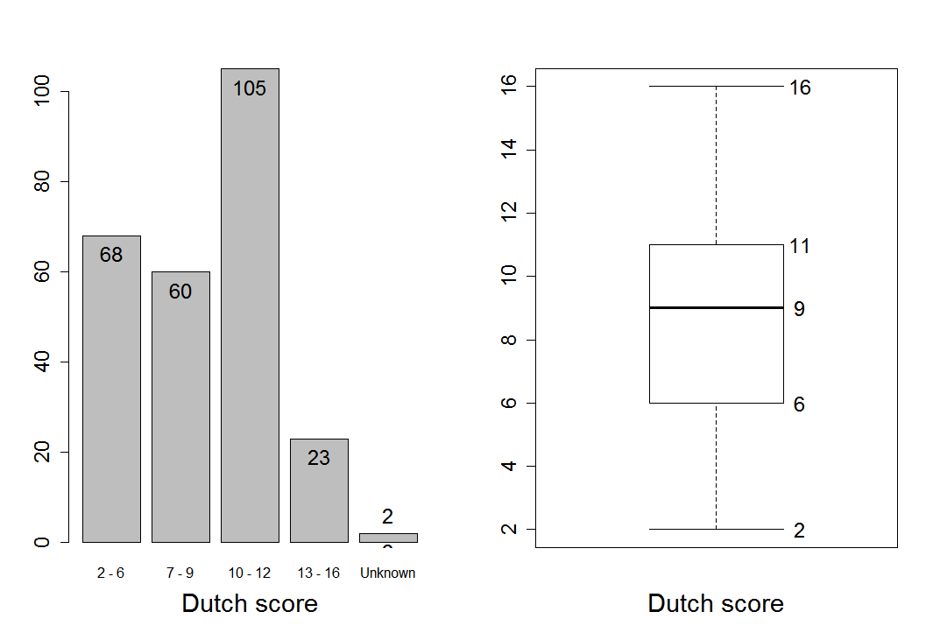

### Fasting lipid profile results used for diagnosis

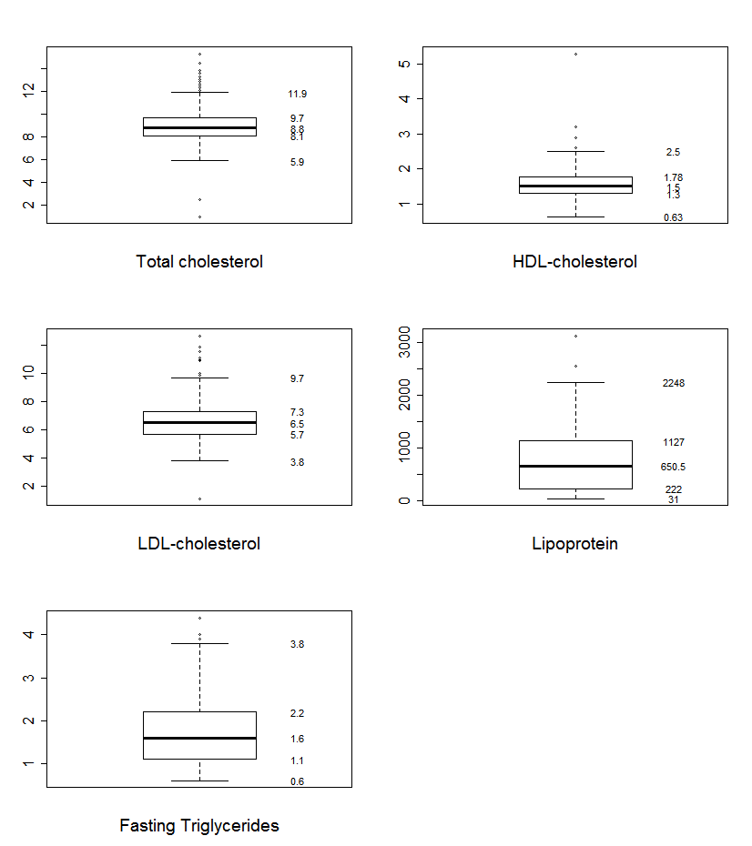

## Potential opportunities for refining the two-step testing strategy

Opportunities originally identified for further efficiency improvements were

1. scoring physical signs of hypercholesterolaemia,
2. taking account of the effect of age on lipid levels,
3. validating MDT assessments,
4. risk scoring for polygenic hypercholesterolaemia - gene sequencing would not be indicated with high LDL SNP score relative to measured LDL-C,
5. reducing the number of mutations which are not reported frequently on UK PASS

database,

1. adapting the set of mutations used in Sequenom testing as the prevalences of mutations in populations of interest becomes better known.

We now look at some of these variables these individually to assess whether there is a correlation between them and the presence of an FH mutation.

1. Scoring physical signs of hypercholesterolaemia

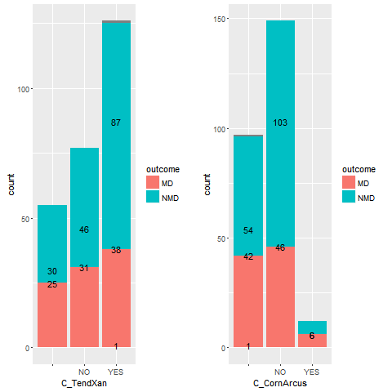

Patients are selected for proband testing on the basis of their Dutch Lipid Clinic Network

Score (DLCNS). The DLCNS might be able to more accurately reflect the risk of carrying an FH mutation if physical signs were scored and the confounding effects of age were reduced.

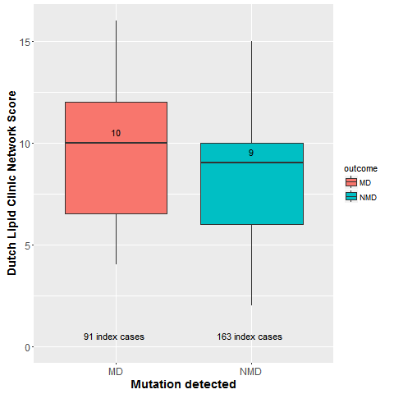

Figure Boxplot of index test Dutch Lipid Clinic Network Score stratified by presence of absence of mutation.

## NonHDL calculation

nonHDLC = TotalC – HDLC

## Multiples of Median of nonHDL

Median values of a nonHDL for a health population were taken from HSE data over years 2003, 2006, 2008, 2012, 2013, 2014.

Value for males: 4 mmol/L

Value for females: 3.8 mmol/L

This allows us to calculate the multiples of median for each participant (MoM).

# Discussion

# References

# Figures

Figure Flow of index cases through the two-stage 'chip and sequence' diagnostic pathway. Retrospective validation testing was carried out to determine the accuracy of the diagnostic strategy.

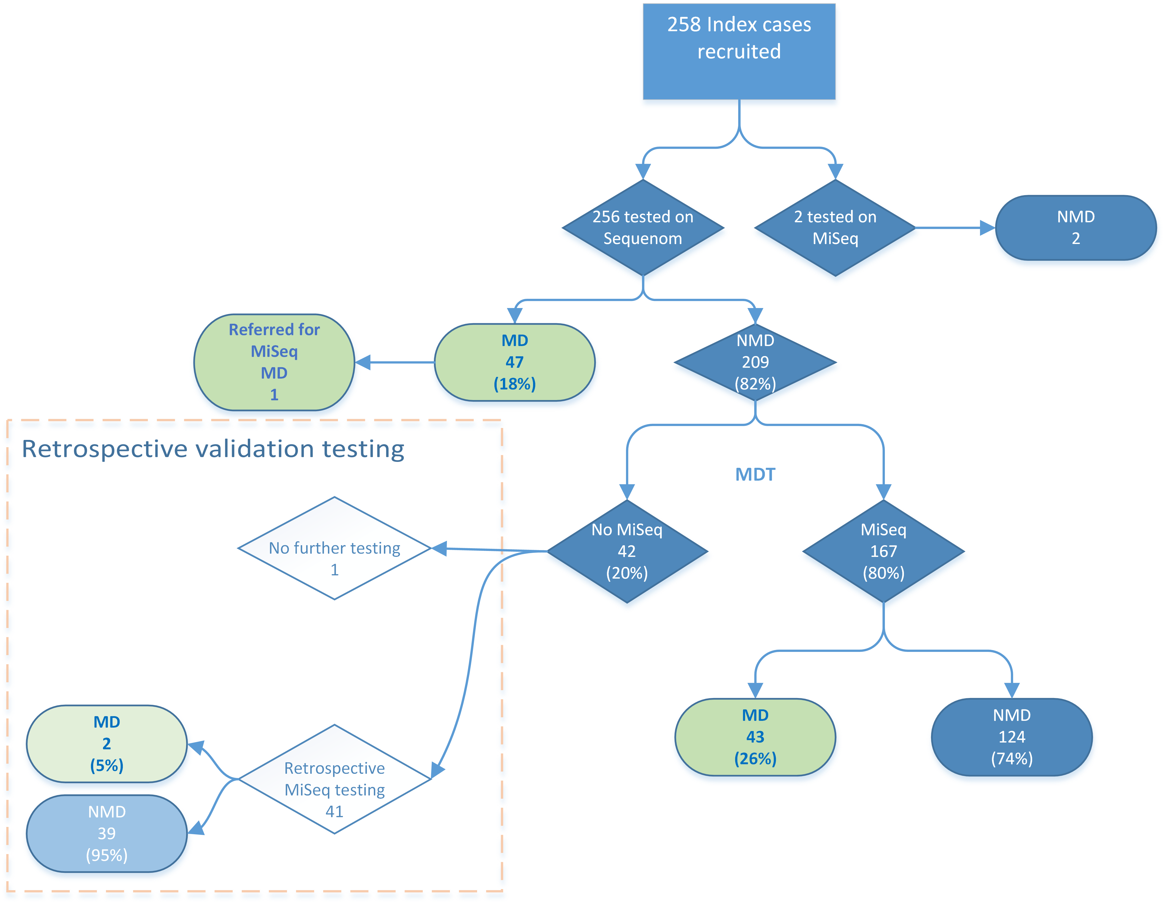

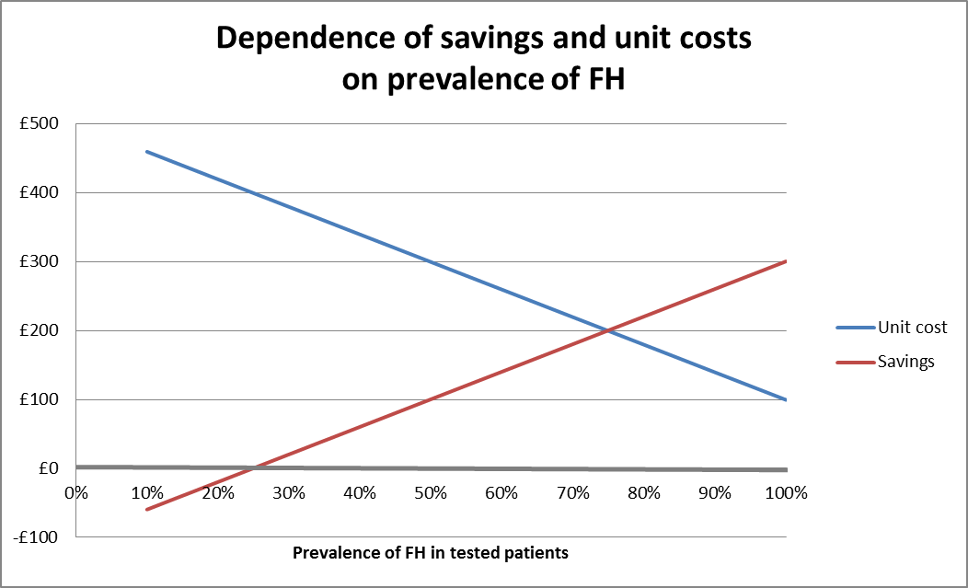

Figure Cost and saving per index case tested; figure shows an increase in the cost savings of the two step testing strategy as the number of mutation positives increase.



Figure 4 Boxplot of index test Dutch Lipid Clinic Network Score stratified by presence of absence of mutation.

# Tables

Table Number of index cases undergoing genetic testing for FH

|  |  |
| --- | --- |
| Total number of patients recruited | 258 |
| Sequenom™ chip testing | |
| Index cases undergoing Sequenom™ chip testing | 256 |
| Mutation detected on Sequenom™ chip (MD) | 47 |
| No mutation detected on Sequenom™ chip (NMD) | 209 |
| Total cost of Sequenom testing | £25,600 |
| NGS sequence testing | |
| Index cases with NMD on chip, undergoing NGS | 167 |
| Index cases with NMD on chip and MD on NGS | 43 |
| Index cases with NMD on both chip and NGS | 124 |
| Total cost of MiSeq testing | £66,880 |
| **Total cost of testing** | **£92,400** |

Table Diagnostic accuracy: mutation detection by the two-stage 'chip and sequence' approach and full genetic testing.

|  |  |  |  |
| --- | --- | --- | --- |
|  | | **Mutation present** | **Mutation absent** |
| Chip and Sequence | **MD** | 90 | 0 |
| **NMD** | 2 | 163 |
|  | | 92 | 163 |

Table Cost comparison of both diagnostic strategies

|  |  |  |
| --- | --- | --- |
|  | **Per patient cost (£)** | **Total cost for cohort (n=256) (£)** |
| **NGS** | £400 | £102,400 |
| **Chip and sequence approach (actual cost from project)** | £358 | £92,400 |
| ***Cost difference (NGS – chip and sequence approach)*** | £42 | £10,000 |

Table Percentage of index cases testing positive for a mutation associated with FH

|  |  |
| --- | --- |
| Percentage MD index cases detected on Sequenom | 18% |
| Percentage of NMD on Sequenom who testing MD by MiSeq | 26% |
| Percentage of index cases found to have a mutation | 35% |

Table Frequency of mutations picked up by Sequenom™ chip test

|  |  |
| --- | --- |
| **Mutation** | **Frequency of detection** |
| ABOB c.10580G>A p.(Arg3527Gln) | 9 |
| LDLR c.1048C>T p.(Arg350*) | 1 |
| LDLR c.1187-10G>A | 1 |
| LDLR c.1359-31_1359-23delinsCGGCT | 3 |
| LDLR c.1444G>A p.(Asp482Asn) | 9 |
| LDLR c.1444G>C p.(Asp482His) | 1 |
| LDLR c.1463T>G p.(Ile488Ser) | 1 |
| LDLR c.1897C>T p.(Arg633Cys) | 5 |
| LDLR c.2054C>T p.(Pro685Leu) | 5 |
| LDLR c.259T>G p.(Trp87Gly) | 1 |
| LDLR c.301G>A p.(Glu101Lys) | 1 |
| LDLR c.313+1G>A | 2 |
| LDLR c.326G>A p.(Cys109Tyr) | 2 |
| LDLR c.660delC p.(Asp221Thrfs*44) | 1 |
| LDLR c.662A>G p.(Asp221Gly) | 1 |
| LDLR c.681C>G p.(Asp227Glu) | 1 |
| LDLR c.682G>T p.(Glu228X) | 2 |
| LDLR c.932_933delAA p.(Lys311Argfs*) | 1 |
| NMD | 209 |
| NOT DONE | 2 |
| Total | 258 |

Table Frequency of mutations picked up by NGS testing

|  |  |  |
| --- | --- | --- |
| **Mutation** | **Frequency of detection** | **Point of detection** |
| APOB c.10397C>A p.(Ser3466Tyr) | 1 |  |
| ApoB c.10740C>T p.(Asn3580Asn) - VUS | 1 |  |
| APOE c.239C>A p.(Ala80Glu) | 1 |  |
| ApoE c.492_493delinsCT p.(Lys164_Arg165delinsAsnTrp) - VUS | 1 |  |
| LDLR c.1019_1020delinsTG, p.(Cys340Cys) | 1 |  |
| LDLR c.1060G>A p.(Asp354Asn) | 1 |  |
| LDLR c.1072T>C p.(Cys358Arg) | 1 |  |
| LDLR c.1211C>T p.(Thr404Ile) | 1 |  |
| LDLR c.1246C>T p.(Arg416Trp) | 1 |  |
| LDLR c.1318A>G p.(Arg440Gly) | 2 |  |
| LDLR c.1371_1374dup p.(Ala459fs) | 1 |  |
| LDLR c.1478_1479dup p.(Val494fs) | 1 |  |
| LDLR c.1486C>T p.(Agr496Trp) | 1 | Retrospective MiSeq testing after MDT decision for no further testing |
| LDLR c.1567G>A p.(Val523Met) | 1 | Retrospective MiSeq testing after MDT decision for no further testing |
| LDLR c.1618G>A p.(Ala540Thr) | 1 |  |
| LDLR c.1684_1686dup p.(Trp562dup) | 1 |  |
| LDLR c.1730G>A p.(Trp577*) | 1 |  |
| LDLR c.1764C>G p.(Ile588Met) | 1 |  |
| LDLR c.1816G>T p.(Ala 606Ser) | 1 |  |
| LDLR c.1876G>A p.(Glu626Lys) | 1 |  |
| LDLR c.1943C>T p.(Ser658Phe) | 1 |  |
| LDLR c.2043C>A p.(Cys681*) | 2 |  |
| LDLR c.2088C>A p.(Cys696*) & PCSK9 c.-331C>A | 1 |  |
| LDLR c.2140+1G>A | 1 |  |
| LDLR c.2389G>A p.(Val797Met) | 1 |  |
| LDLR c.2412G>A p.(Leu804Leu) | 1 |  |
| LDLR c.257delT p.(Phe86fs) | 1 |  |
| LDLR c.302A>G p.(Glu101Gly) | 1 |  |
| LDLR c.326G>A p.(Cys109Tyr) | 1 | Found on both Seq and MiSeq |
| LDLR c.501C>A p.(Cys167*) | 2 |  |
| LDLR c.502G>A p.(Asp168Asn) | 2 |  |
| LDLR c.532G>T, p.(Asp178Tyr) | 1 |  |
| LDLR c.564C>G p.(Tyr188*) | 1 |  |
| LDLR c.621C>T p.Gly207Gly | 1 |  |
| LDLR c.663_683dup p.(Asp221_Asp227dup) | 1 |  |
| LDLR c.685G>T p.(Glu229*) | 1 |  |
| LDLR c.694+3_694+19del | 1 |  |
| LDLR c.862G>A, p.(Glu288Lys) | 1 |  |
| LDLR c.912C>G p.(Asp304Glu) & LDLR c.2096C>T p.Pro699Leu) | 1 |  |
| LDLR c.938_939delinsAT p.(Cys313Tyr) | 2 |  |
| PCSK9 c.113A>G p.(Tyr38Cys) | 1 |  |
| **Total** | **46** |  |